Course Handout:
Top tips to embed SEL into your classroom

MODULE 1 - Getting started
LESSON 2 - SET SOME LEARNING GOALS
LESSON ACTIVITY
Answer the following questions to help you identify your learning intention for this course and the success criteria you’ll use to measure the outcomes:
- Why are you excited to take this course? In what ways will this course help you in the classroom?
- What do you already know or understand about embedding SEL into the classroom? How would you define SEL?
- List 3 things you are unsure of or would like to know more about SEL.

MODULE 2 - Introduction to social and emotional learning

LESSON 1 - WHAT IS SOCIAL AND EMOTIONAL LEARNING?

SEL programs are essential for cultivating a nurturing and supportive school environment and fostering a sense of safety and belonging for young people to flourish. SEL is recognised for its significant impact on children's overall well-being, mental and physical health, social and relational growth, and the development of essential life skills.

Within the Australian Curriculum, SEL is embedded through Personal and Social Capability as students learn to understand themselves and others and effectively manage their relationships, lives and work - all underpinned by reflective practice.

SN Elliott, Journal of Applied Developmental Psychology, 2017, focuses on the growing worldwide contention that children need more than traditional academic skills to thrive in the 21st Century. They suggest that learning social and emotional skills will support academic learning and the challenges that arise while helping to prevent risky personal behaviours and prepare them for the demands of life.

LESSON ACTIVITY:
Read through the Personal and Social Capability (v9) to familiarise yourself with the goals of this capability within the Australian Curriculum, then answer the following questions:
- What are the 4 concepts/domains of the Personal and Social Capability?
- What would each domain look like in practicality? Write 1-2 examples of what you could expect to see or hear in your classroom.

LESSON 2 - WHY IS SEL IMPORTANT?
LESSON ACTIVITY
Read this article by Professor Helel Cahill from the University of Melbourne, as it unpacks the importance of delivering high-quality SEL lessons to young people in the wake of disruptors such as the COVID-19 pandemic.
How social and emotional learning can help our school kids cope | Pursuit by The University of Melbourne
Think back to your own school experience and consider what Social Emotional Learning you would have benefited from. List 3 SEL skills you wish you had been taught.

LESSON 3 - WHERE DOES THIS FIT IN THE CURRICULUM?
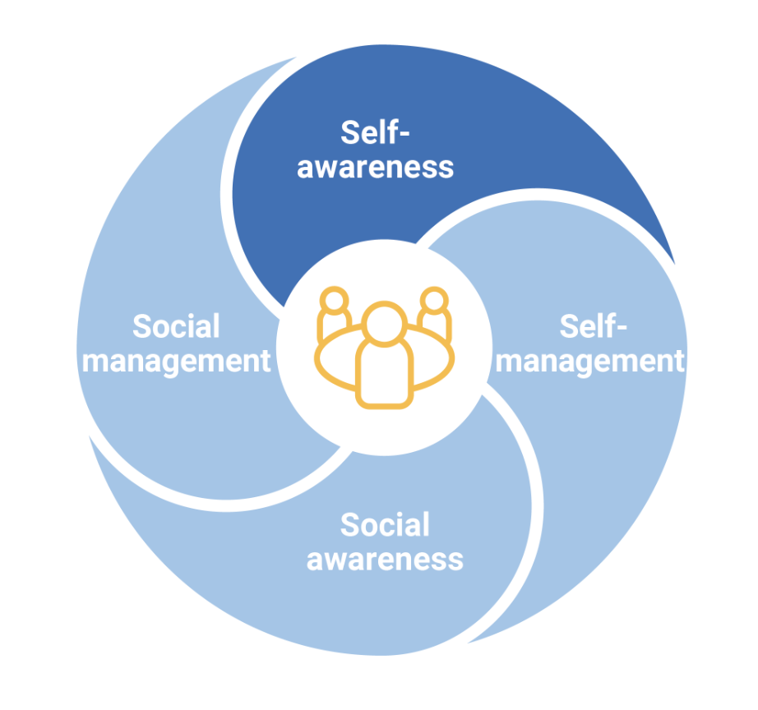
(Image sourced: Australian Curriculum)

LESSON ACTIVITY

Complete the following questions to reflect on the 4 domains of the Personal and Social Capability and how you may already be assisting your students to practise these skills on a regular basis.

- How could these domains be addressed through the curriculum you teach? Which domain/s lend themselves best to your subject area? Which domain/s are difficult to practise? Why?
- What are some activities you regularly facilitate that would assist students in practising skills for each domain?
- What are some new activities you could facilitate to assist students in practising each domain (try to generate ideas for the domain least practised)?

MODULE 3: Embedding SEL concepts into everyday teaching and learning

LESSON 1 - WHAT ARE THE KEY SEL CONCEPTS DELIVERED BY LIFECHANGER?
Embedding SEL into your classrooms should involve a combination of explicit and implicit instruction, as well as regular opportunities for practice. This is why LifeChanger Foundation and Cool have created a series of SEL lessons (10 of the 35) specifically designed to promote ongoing conversations and application of skills.

As a starting point, peruse the lessons below and identify the ongoing practice activities for each (featured in the Thrive section of the lesson).

Pillar | Description | Lesson plans
Health | The Health Pillar addresses how movement, nutritional awareness, recovery and mindfulness can enhance feelings of positive well-being and develop students’ self-awareness and connection between body and mind. | - Mindset and self-talk  - Mindfulness
Skills | The Skills Pillar focuses on building resilience and life skills such as goal-setting, problem-solving, resilience and gratitude to help students effectively work through challenges. | - Goal Setting  - Building Resilience Through Problem-solving and Gratitude
Self | The Self Pillar assists students to enhance their self-awareness and practise self-regulation. They learn how to identify their thoughts and emotions and reflect on how these influence their behaviours and actions. | - Identifying Strengths  - Self-Talk to Manage Emotions
Purpose | The Purpose Pillar helps students reflect on their passions, hobbies and interests and recognise how these can help provide a sense of purpose and direction in life as they explore future pathways. | - Identifying Skills and Strengths  - Growing Towards Life Goals
Tribe | The Tribe Pillar encourages students to form deeper connections with their peers, family members and community. They also evaluate their friendships to recognise how they can support and value themselves and others. | - Building Healthy Relationships  - Creating Support Networks

LESSON ACTIVITY
After perusing the lessons in the table, reflect on the following questions:
- Which lesson stood out to you as one your students would benefit from? In what ways?
- What changes would you hope to see in your students as a result of implementing this lesson?
- Which SEL concepts are driving the lesson you selected?

LESSON 2 - DEVELOPING PERSONAL CONFIDENCE WITH SEL

Suggestions for developing your personal understanding and confidence in SEL delivery
- Keep a journal
- Daily meditation
- Identifying areas of stress in your home and work life
- Develop personal strategies to use in these moments
- Take regular breaks
- Regularly check in with yourself
- Chat to your school leadership team about staff well-being
- Ask for support when needed
- Prioritise your social and emotional health

LESSON ACTIVITY
Reflect on how you look after your own emotional, social and physical health by answering the following questions:
- Are there areas you want to work on in your social and emotional health?
- Do you have any ideas you’d like to try? (e.g. journaling, meditation, etc)?
- Who are the people you can turn to for support?
- How do you meet your emotional health needs?
- How do you meet your social health needs?
- What indicators appear when these needs are not being met?

LESSON 3 - HOW CAN THIS BE EMBEDDED IN MY CLASSROOM?
LESSON ACTIVITY - Unplanned SEL
Consider how you could apply unplanned SEL teaching to the following scenarios:
Scenario 1:
You have a class straight after lunch on a Friday afternoon. As everyone enters the room, you notice 2 students who ordinarily sit together are at opposite ends of the room, avoiding eye contact and looking upset. You suspect some sort of conflict has occurred during lunchtime.
Scenario 2:
You are in the middle of teaching a lesson when 1 student raises a question about how the information they are learning is relevant to the real world, and they make a comment about how “they will never actually use this in their real lives.”
Scenario 3:
You are preparing students to complete an oral presentation to their classmates. Several students express how they are extremely nervous and feel as though they can’t present to the whole class and have asked if they can present to you privately instead.

LESSON ACTIVITY - Planned SEL

Planned SEL
7 ways to embed SEL into your everyday teaching practice:
- Feedback
Consider the way you provide feedback to students. Ensure the feedback encourages students to reflect on their learning and identify strengths and areas for improvement. This could also include students setting goals for future learning based on the feedback received.
- Group work
Require students to use relational skills such as listening, responsibility, communication and problem-solving. Not all students will enjoy group work, so this can be a valuable skill they can learn as they understand the benefits.
- Providing the ‘why’ behind learning
As a teacher, you would have heard more times than you can count a comment from a student questioning the importance or necessity of what is being taught. One of the best ways to include SEL is by outlining ‘why’ in your introduction to a unit of work or lesson; this can give students a sense of purpose in their learning beyond the content itself, for example critical thinking, working as a group, building confidence, etc.
- Building SEL vocabulary
This could be as simple as helping students label and articulate emotions as they arise, such as “I can see you are finding this task challenging. That must be frustrating for you.” Just including the word frustrating exposes students to understanding an emotion they may not have labelled before.
- Role modelling
This is discussed in greater detail in Module 4; however, considering yourself as a role model for SEL is an easy way to expose students to strategies to build their emotional and social capabilities. You may use tools such as storytelling or verbal observations of your thoughts and feelings, such as “I just need to take a deep breath to focus myself before we start the lesson.” This modelling allows students to see SEL in practice.
- Encourage debate and critical thinking
Debating topics is a healthy way for students to consider others' perspectives and build empathy, important components of SEL. Rather than asking students to share what they know, encouraging them to share what they think can be a simple and effective tool to promote critical thinking.
- Labelling the SEL learning
This could look like many things within the classroom. For example, suppose you have noticed students working effectively and productively. In that case, you might immediately provide this feedback, labelling their skills or any strategies you can see them using, such as excellent listening skills, flexible thinking or positive self-talk.

Recommended readings for embedding SEL into the classroom:

- Overcoming The Barriers To Implementing SEL
- 20 Ways to Incorporate Social-Emotional Learning in Your Classroom | by EQ Explorers Team | Educate. | Medium
- 12 Interesting Social-Emotional Learning Activities for Classroom
- 3 SEL Practices Teachers Can Use Every Day

LESSON 4 - SETTING SEL GOALS
LESSON ACTIVITY
Download 1 of the SEL lessons using the link below and answer the following questions:
Self: Identifying Strengths
Tribe: Effective Communication
- Read the lesson plan and identify the SEL concepts that are delivered in this lesson.
- Consider how you could teach this concept indirectly or during an everyday lesson, as well as some ways you could help embed the learning through regular practice.

MODULE 4: Role modelling SEL
LESSON 1 - HOW TO ROLE MODEL SEL
LESSON ACTIVITY
After watching the video presented by the LifeChanger Foundation team, complete the following quiz to check your understanding.
Question 1:
According to Albert Bandura’s Social Learning Theory, a person will learn to replicate a behaviour based on a specific learning process. Which of the following correctly outlines the process mentioned in the video?
- Motivation, notice, replicate, remember
- Notice, remember, replicate, motivation
- Notice, replicate, remember, repeat
Question 2:
What would be an effective way to model self-awareness to your students? Note: there is more than 1 correct answer.
- Demonstrating patience when tested
- Letting your students know when you’re tired and why
- Telling the students which staff members you like and dislike
- Admitting when you made a mistake or assumption

Question 3:
In the video, the presenter mentioned several ways to demonstrate attentive listening. Which of the following was NOT recommended?
- Asking genuine follow-up questions
- Recalling conversations and experiences the speaker has previously shared
- Relaying key ideas back to the person speaking
- Interrupting the person speaking to share your own experience

ANSWERS:
- B. First, they notice the person's actions, gestures and facial expressions. Then they remember the behaviour. Next, they replicate the behaviour on their own. And finally, if the outcome was positive, they gain the motivation to continue.
- A. and D. Modelling patience, honesty and openness can help build genuine and respectful relationships with your students. However, try to avoid over-sharing or sharing anything that could be viewed as disrespectful or unprofessional.
- D. Attentive listening involves focusing on the person speaking and not interrupting them mid-conversation.

MODULE 5: Upskilling and supporting other teachers to adopt a uniform approach
LESSON 1 - A UNIFORM APPROACH
LESSON ACTIVITY
Research your school’s approach to teaching SEL:
- Can you identify how SEL is mapped across year levels?
- What is the focus within each year level?
- Where is SEL being explicitly delivered?
- How could suggestions be made to tighten the delivery and impact of SEL lessons?
LESSON 2 - SUGGESTIONS FOR COLLABORATION IN YOUR LEARNING COMMUNITIES
Don’t just keep this knowledge of SEL and how to embed it into your teaching practice to yourself! Spreading your learning across the school will raise the standard of your learning community and improve outcomes for all students, not just those lucky enough to be in your class.
Here are some ways to approach collaboration with your peers and learning community about the ideas and skills you have covered in this course.
1. Micro-PD session
Ask a colleague if they have 10-15 minutes to chat with you after classes are done for the day. Give them a brief overview of the course, what you liked and learned, what you’re still wondering, and your initial thoughts on how to incorporate this learning into your current practice. Use this course handout, as well as your thoughts from the learning goals reflections activity, to structure your thinking. Or perhaps there is a video or story on the course handout that you think will be of particular interest and could be used to spark a discussion.
Your colleague might have questions about your understanding of the course, or they might have their own creative ideas about where to take it next. Look at you go: instant collaboration!
Schedule another quick coffee break in a few weeks where your colleague can follow up with you and keep you accountable for growing your practice so that you don’t forget everything once the course is finished.
Alternatively, you might volunteer to present at your next PLC or staff meeting and really expand your colleague’s practice.
2. Set up an observation
One of the most effective ways to improve your classroom practice is to have a colleague observe you in action and provide feedback.
Observations can seem intimidating and uncomfortable, especially if you haven’t had any experience with them since your days as a graduate teacher. A helpful way of approaching the experience is to view it as a collaboration meant to benefit all involved, not as 1 teacher judging their colleague. The teacher being observed will receive useful feedback that might not be revealed through the use of other assessment methods, especially self-reflection. It’s a different perspective. For the one observing, the experience can provide an opportunity to learn from seeing a fellow teacher in action.
It can be difficult to schedule a time when both teachers are free for an observation. Consider combining your classes for a period so that 1 teacher can take on instructional duties for the whole, allowing the other teacher to observe while still supervising their class.
It’s important to set clear goals for yourself during this observation and to make time to debrief afterwards. Use this template to structure your observation and collaborate with your colleague before and after the session. This is so that they are aware of what learnings from the PD you are trying to implement and so that you are clear about what you are aiming to achieve.
3. Plan with your PLC about how to implement this course
When teachers collaborate, the interests, backgrounds and strengths of each teacher can contribute to a project. If teachers work in a team, they can delegate tasks according to the personality and expertise of each team member. This type of teamwork contributes to a greater sense of trust and accountability, allowing teachers to feel confident about contributing their most dynamic skills toward school improvement.
While this is quite an involved collaborative effort, you will find it to be highly effective, as you will benefit from your colleagues sharing their creativity, experience, unique approaches and individual strengths with regard to this PD. You will be able to take the time to plan a structured approach to incorporating this learning into your practice and will benefit from the support and reflection of your team working together to improve your practice.
LESSON ACTIVITY
Set up a meeting with a colleague or relevant leader in your school to discuss the implementation of SEL within your teaching practice. Additionally, consider the ways these lessons could be disseminated across your school community to provide students with opportunities for SEL.

MODULE 6: Disseminating LifeChanger concepts throughout the school
LESSON 1 - COOL LESSON PLANS
CLICK HERE to view the full set of lesson plans.
LESSON ACTIVITY
Spend some time perusing the SEL lessons available on the Cool Australia website, then select 2 lessons you want to implement with your class. Set a SMART goal to help you stay accountable.
SMART is an acronym that stands for:
- Specific
- Measurable
- Attainable
- Relevant
- Time-Bound
For example, you wouldn’t set a goal such as ‘I want to implement the lesson Vision Boarding because it will benefit my students and help them with their futures.’
When setting your goal, ensure it meets all of the SMART criteria.
Set your SMART goal:

MODULE 7: Reflection
LESSON 1 - COURSE REFLECTION
LESSON ACTIVITY
Consider how this course has helped grow your knowledge and/or confidence and answer the following questions:
- What’s 1 new thing you’ve learned and would like to apply?
- How has this course helped increase your confidence in embedding SEL?
LESSON 2 - TAXONOMY OF LEARNING
LESSON ACTIVITY
Thinking about the course, choose 1-2 reflection strategies from the taxonomy of learning and apply them to the course.

