Course Handout
What’s the secret sauce for delivering SEL? (facilitation tips)

MODULE 1 - Getting started
LESSON 2 - SET SOME LEARNING GOALS
LESSON ACTIVITY
Answer the following questions to help you identify your learning intention for this course and the success criteria you’ll use to measure the outcomes:
- Why are you excited to take this course? In what ways do you think this course will help you in the classroom?
- What are some effective facilitation techniques you could apply to SEL?
- List 3 things you are unsure of or would like to know more about SEL.

Learning intention:

Success criteria:

MODULE 2: Creating a safe and supportive environment
LESSON 1 - HOW DO I CREATE A SAFE AND SUPPORTIVE LEARNING ENVIRONMENT?

LESSON ACTIVITY

Video notes:

Key points:

Questions:
- What are you already doing that works?
- What else could you be doing?

Next, read the following articles and identify which tips are commonly suggested across all platforms.

Supporting Articles:
- 20 Tips for Creating a Safe Learning Environment | Edutopia
- Feeling safe at school – what does the research say?
- Creating a supportive learning environment | Classroom resources | ReachOut Schools

Top 3 tips:

MODULE 3: Increasing student engagement
LESSON 1 - HOW DO I INCREASE STUDENT ENGAGEMENT?

LESSON ACTIVITY
Answer the following questions:

- Identify which of these is NOT a sign of physical engagement:
- Leaning forward
- Nodding heads
- Responsive to questions
- Attentive eye contact and raising their hands

2. List 3 physical signs that would signal students are not engaged in the workshop.

3. What is positive reinforcement, and how could this look in your SEL lessons?

4. Reflect on the physical engagement strategies presented. Choose 1 you would like to try in an upcoming class and set yourself a goal to do this.

ANSWERS:
- C. Responsiveness to questions is an example of cognitive engagement.
- Body language is closed off, slouching, not making eye contact, constantly fidgeting and/or moving, asking to go to the bathroom regularly, etc.
- Reinforcing the behaviour we would like to see more of from students must be authentic and specific, for example, “That was really clearly communicated,” or “I liked the way you were nodding your head and holding eye contact during that conversation,” or “It was great to see you pause before you responded. It shows you were really thinking about that response.”

LESSON 2 - SUSTAINING STUDENT ENGAGEMENT: ADDITIONAL RESOURCES

While focusing on building student engagement throughout SEL lessons is excellent, ongoing engagement includes more than just what takes place within the lesson. Moreover, we need to have a strong personal understanding of why student engagement is an important part of your teaching pedagogy to ensure the motivation for increasing capacity to engage students is paramount in SEL delivery.

LESSON ACTIVITY
Read the article Building and Sustaining Student Engagement to improve your understanding of the importance of student engagement to student learning and outcomes.

Then, answer the following questions:
- On page 2, what were the 4 components of student engagement discussed?

Answer: Motivation and engagement, connectedness, continuum of engagement and parent connectedness.

- In your own words, describe why student engagement is important.

Finally, determine 2 things you will trial in an upcoming class to boost student engagement, such as encouraging independence through a task that students can choose in their learning activity or introducing an intentional physical break every 15 minutes.

Additional Supporting Articles:
- Increasing Student Engagement | Teaching Commons
- How to Keep Kids Engaged in Class | Edutopia
- Engaging students in learning
- ​​Student Engagement K-12
- Mapping research in student engagement and educational technology in higher education: a systematic evidence map

MODULE 4: Encouraging open sharing
LESSON 1 - HOW DO I ENCOURAGE STUDENT SHARING?

LESSON ACTIVITY

Complete the following questions to apply what you’ve learned from the video:
- Provide an example of when or how you could use ‘probing.’ Provide an example of when this technique may not be appropriate.
- Why is acknowledging student contribution important, and how does this increase their likelihood to share?
- Consider some of the students in your class. Who are your shy students? What strategies would help them to share?

Put it into practice - in your next lesson, try some of these techniques to increase student sharing and see what works!

LESSON 2 - HANDS, HEART AND HEAD OF FACILITATION SKILLS

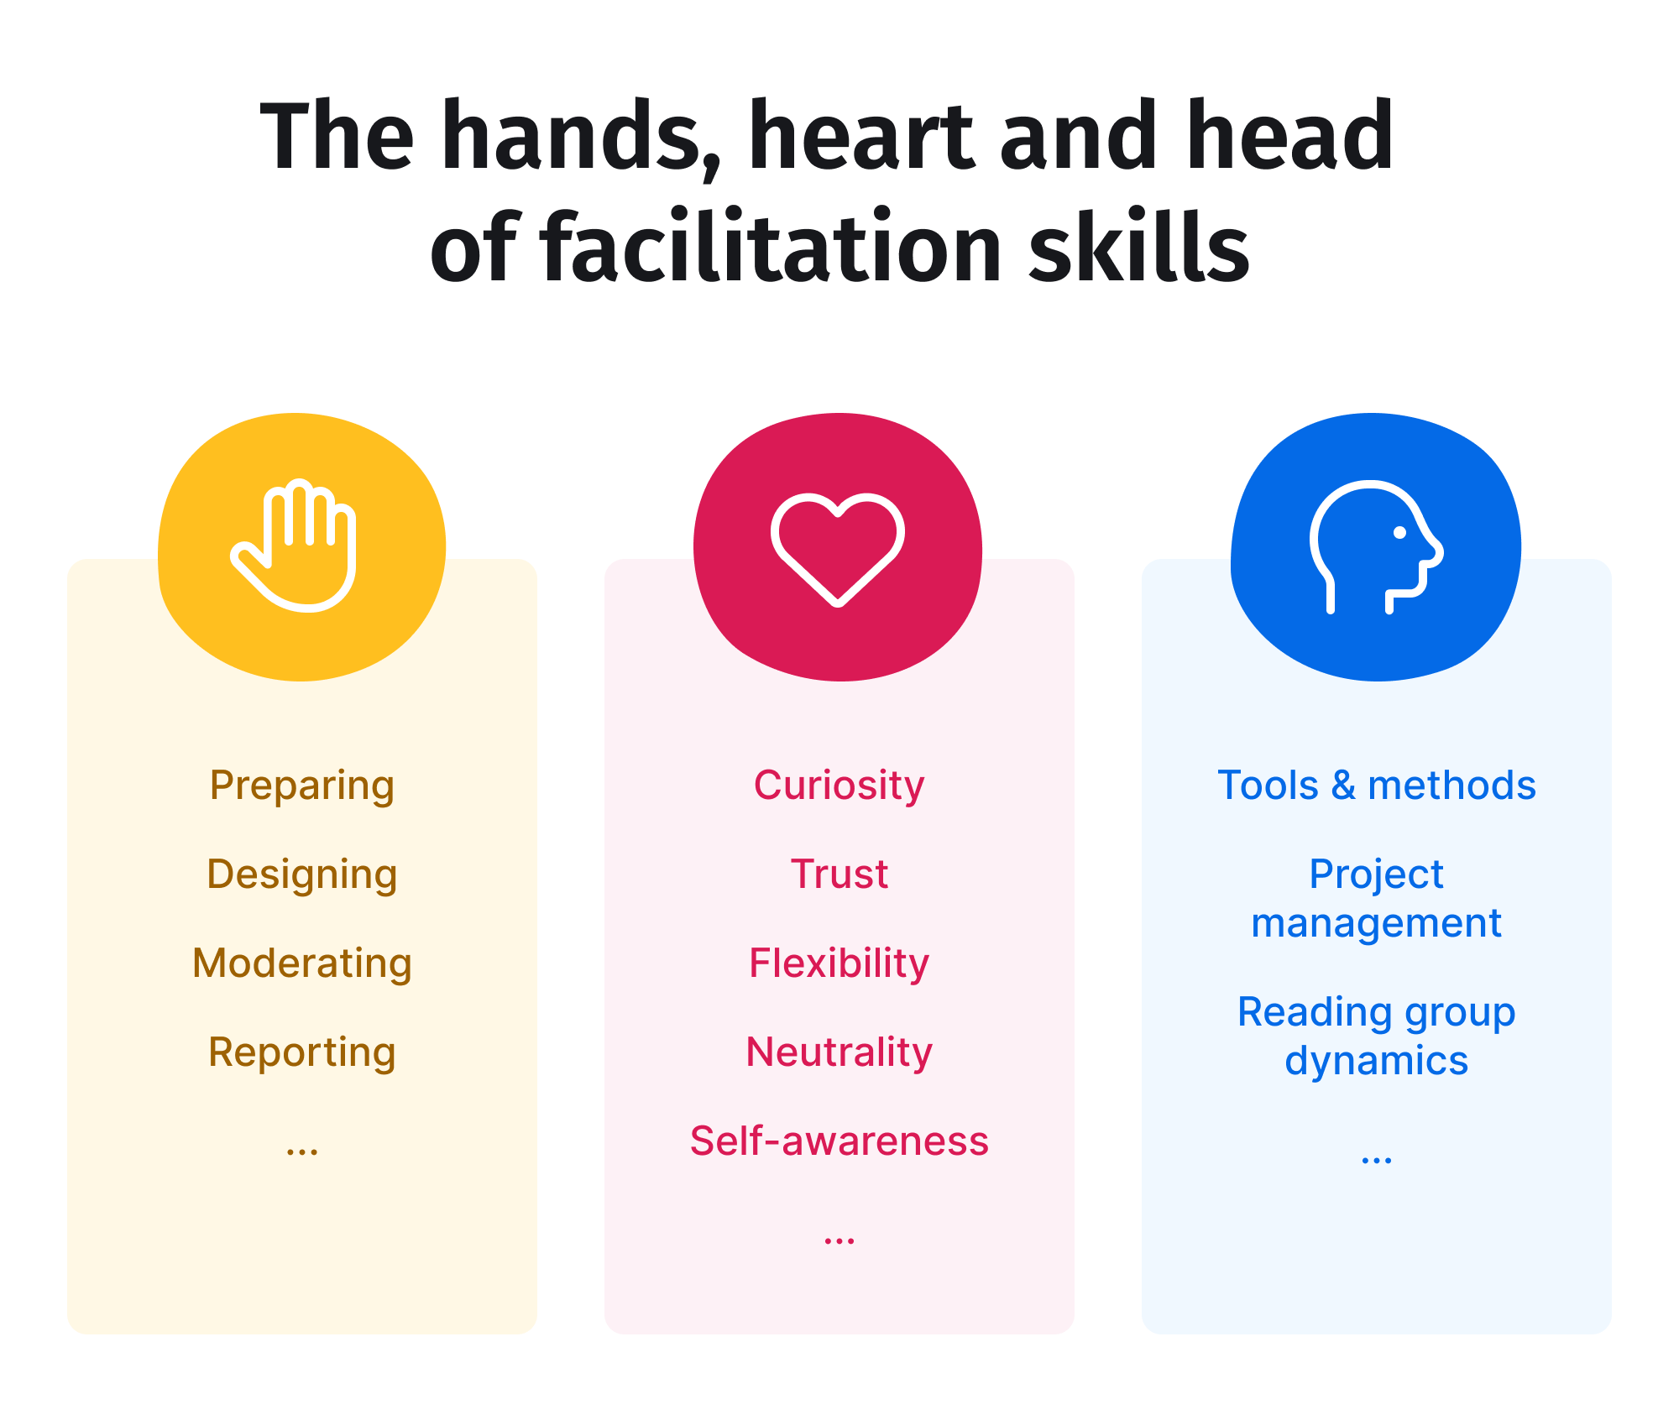
(Image Source: Session Lab)

Hands
The practical skills of preparation, thoughtful design, adept moderation and comprehensive reporting, to enable you to engage young people successfully.
- Preparing: Thoroughly prepare for each facilitation session, including researching the topic, tailoring content to your specific audience and gathering necessary materials.
- Designing: Structure your sessions thoughtfully to achieve the desired outcomes. Consider the flow of activities, the balance between individual and group work and how to encourage active engagement.
- Moderating: Guide discussions and interactions, ensuring that everyone has a chance to participate. Manage any conflicts that may arise and steer the conversation towards productive outcomes.
- Reporting: After each session, summarise key points, outcomes and action items. Share relevant information with stakeholders (such as other teachers, leadership staff and parents) and use feedback to improve future facilitation efforts.

Heart
Cultivating a compassionate and self-aware approach by building trust and staying curious, flexible and neutral to create a supportive and inclusive environment.
- Curiosity: Cultivate a genuine interest in the perspectives, ideas, and experiences of young people. Ask open-ended questions and actively listen to their responses to foster engaging discussions.
- Trust: Build a foundation of trust. Demonstrate reliability, confidentiality and a non-judgmental attitude, creating a safe space for open dialogue.
- Flexibility: Adapt your approach to meet young participants’ diverse needs and preferences. Be open to exploring new ideas and accommodating different learning styles.
- Neutrality: Remain impartial and objective during discussions, avoiding personal biases or favouritism. Encourage equal participation and ensure everyone's voice is heard.
- Self-Awareness: Reflect on your own beliefs, values and emotions. Understand how they may influence your facilitation and be mindful of maintaining a positive and constructive atmosphere.

Head
Equipping yourself with essential tools, project management skills and a deep understanding of group dynamics to ensure smooth and effective sessions.
- Tools and Methods: Familiarise yourself with a wide range of facilitation tools and methods, such as icebreakers, brainstorming techniques and group activities. Choose the most suitable ones for specific objectives.
- Project Management: Plan and organise your facilitation sessions effectively. Set clear goals, create agendas, manage time wisely and follow up with any necessary post-session tasks.
- Reading Group Dynamics: Develop an understanding of group dynamics to anticipate and address potential challenges. Recognise individuals’ roles within a group and employ strategies to maintain a harmonious atmosphere.

LESSON ACTIVITY
Reflect on the following questions:
- Which of hands, heart or head of facilitation do you find the easiest?
- Which area would you like to work on and why?
- What could you do to work on this area of your facilitation skills?
- Identify an upcoming lesson to practise this skill and schedule time to reflect on the delivery of this lesson.

(Optional) Read the linked articles for additional information on questioning strategies within the classroom:
- How to Improve Your Facilitation Skills (and Be a Great Facilitator) | SessionLab
- Questioning Techniques and Teachers’ Role in the Classroom
- Questioning
- Key Questioning Strategies

MODULE 5: What role does vulnerability play?
LESSON 1 - WHAT ROLE DOES VULNERABILITY PLAY IN TEACHING?

LESSON ACTIVITY
Reflect on what vulnerability means to you and write your own definition.

At the end of the video, the LifeChanger facilitator posed several questions. Take some time to answer these:
- What’s 1 personal experience you could share that would help build a deeper connection with your students?
- What would they learn and how could they apply it to their own lives?
- What details would you need to omit or change to make it age and stage appropriate?
- And finally, after watching this video, do you have the confidence to openly share this experience with your class?

Supporting articles:
- Risk and Protective Factors for Youth
- Brené Brown Vulnerability, Losing Armor, and Gaining Power | CRM.org
- Forbes Brene Brown Vulnerability
- High-Impact Wellbeing Strategies
- (PDF) Developing Positive Relationships in Schools
- Teens And Peer Relationships
- 10. Adolescents’ Resilience | Growing Up in Australia

LESSON 2 - STEPPING INTO VULNERABILITY

LESSON ACTIVITY

Download and read the following lesson plan:

Tribe: Healthy Relationship with Adults

After reading, determine what you could share to help students understand the complex relationship between children and their parents/guardians.

MODULE 6: How to discuss tricky and sensitive topics
LESSON 1 - HOW TO ARTFULLY FACILITATE DISCUSSIONS AND DEBRIEFS INVOLVING TRICKY OR SENSITIVE TOPICS?

LESSON ACTIVITY
Consider the students in your school to who you will deliver SEL content and respond to the following questions:
- What kind of tricky or sensitive topics might you expect to arise?
- Reflect on a time when a tricky conversation has come up in your classroom; how did you manage this? What would you do differently next time?

The following articles can be read to support learning:
- ASKING QUESTIONS TO SUPPORT STUDENT LEARNING IN CLASS: STRATEGIES AND TIPS FOR SMALL-GROUP TEACHING
- Classroom dynamics - Glen Pearsall
- Encouraging Quality Classroom Discussions

MODULE 7: Reading the room
LESSON 1 - HOW DO I READ THE ROOM AND RESPOND ACCORDINGLY?

LESSON ACTIVITY
Reflect on the content presented in the video, and answer the following questions to check your understanding:
- What signs can you look for when reading the room, and what do these signs tell you?
- What signs can you listen for when reading the room, and what do these signs tell you?

Classroom Challenge:
In your next lesson, observe the signs of engagement within the classroom. Use the following prompts in your reflection:
- When was the energy highest? Lowest?
- What signs did you see and hear that indicated engagement or lack of engagement?
- How did you identify the ‘crest of the wave’?

Optional readings to build on learning:
- Reading the Room Gives You an Edge — No Matter Who You're Talking To
- Classroom practice
- Capturing how teachers move around the classroom
- How Taking a Walk Around Your Classroom Can Help You & Your Students

MODULE 8: SEL Lessons
CLICK HERE to view the full set of lesson plans.
LESSON ACTIVITY
Check out all of the SEL lessons and identify a series of lessons or modules that would be most beneficial for your students. Try to carve out 1 hour per week to teach each lesson, or cherrypick your favourite activities and facilitate them during homeroom/tute groups.
MODULE 9: Reflection
LESSON 2 - REFLECTION
Reflection is an important part of learning and is an integral part of good teaching practice. Take a moment to reflect on the learning that has taken place throughout the course.
LESSON ACTIVITY
Complete a 5, 4, 3, 2, 1 reflection. This includes:
- 5 things you’ve learned:

- 4 things you’re taking away to implement:

- 3 things you enjoyed:

- 2 questions you still have:

- 1 person you will share this with:

